# WEEK-1 1.1 - working of lists

**AIM:** Write a HTML program, to explain the working of lists.

**DESCRIPTIONS:**

This HTML document is a simple **demonstration of various types of lists** in HTML.

* <!DOCTYPE html>: Declares the document type as HTML5.
* <html lang="en">: The root element of the page, specifying that the language is English.
* <head>: Contains metadata like the character set and title.
* <meta charset="UTF-8">: Sets character encoding to UTF-8 (to support all text and symbols).
* <title>: Specifies the title of the page (displayed in the browser tab).
* bgcolor="lavender": Sets the background color of the webpage.
* <h1> </h1> is a A top-level heading showing the page purpose.
* <ol>: Creates an ordered (numbered) list.
* <li>: Each list item.
* <ul>: Unordered (bulleted) list.
* <li>: Each bullet point.
* This is a **nested list**: an unordered list inside an ordered list • This is the reverse nesting: an ordered list inside an unordered list
* intended to create a **Definition List**, but there are a few **errors**:
* d1 should be dl (definition list).
* <<dd> is invalid; it should be <dd>.
* The last </dd> and closing tags are missing.

**Program:**

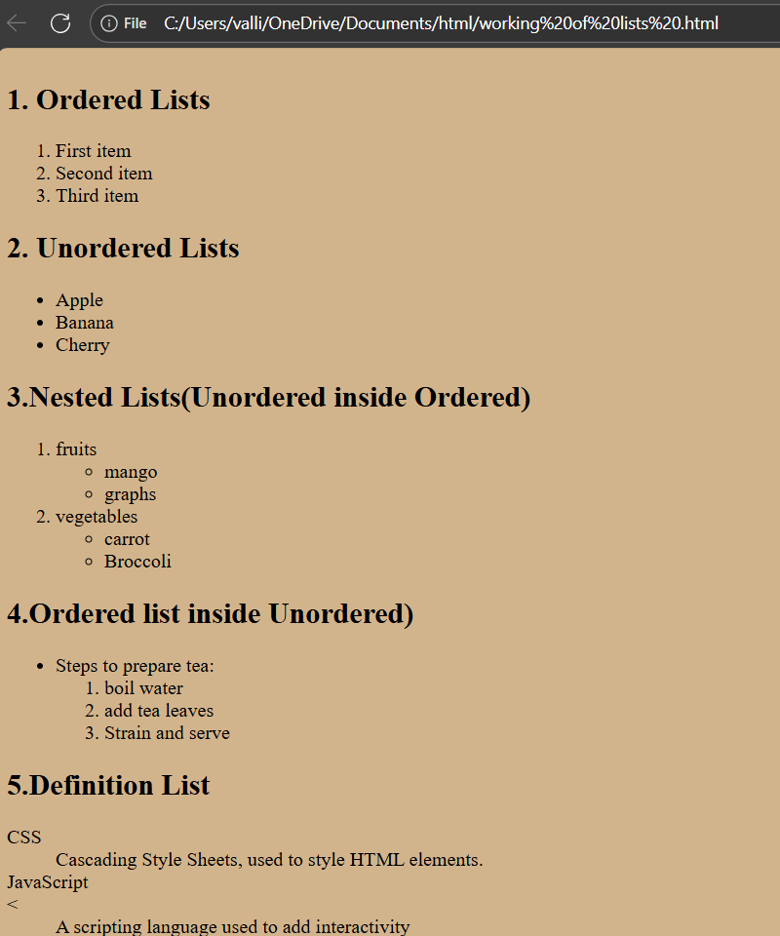

**1.2 working of hyperlinks**

**AIM:** Write a HTML program, to explain the working of hyperlinks using tag and href, target Attributes.

**DESCRIPTION:**

This HTML code demonstrates how to create hyperlinks in a webpage using the <a> tag. It includes two types of hyperlinks: a text hyperlink and an image hyperlink. The first example shows a text link that uses the <a> tag with the href attribute to specify the URL of the Aditya Engineering College website. The target="_blank" attribute ensures that the link opens in a new browser tab. The second example is intended to show an image hyperlink, where clicking on an image redirects the user to the same website. However, the image element (<img src="..." />) is missing, and there is a typo in the heading (&li;a&gt; should be corrected to <a>). Also, the <a> tag for the image hyperlink is not closed properly, and the entire HTML structure is incomplete because the closing tags for <a>, <html>, and possibly others are missing. Fixing these issues would make the example fully functional.

**Program:**

<!DOCTYPE html>

<html lang="en">

<head>

<meta charset="UtTF-8">

<title>Hyperlink Example</title>

</head>

<body>

<h1>Demonstrating Hyperlinks in HTML</h1>

<!--Text Hyperlink-->

<h2>1.Text link using &lt; a&gt, href and target="_blank"</h2>

<p>

Visit <a href="https://www.aec.edu.in/"target="_blank">Aditya Engineering College Website</a>.</p>

<!--Image Hyperlink-->

<h2>2.Image Link using &lt;a&gt; and href</h2>

<p>

Click the image below to visit the <strong>Gallery Page</strong>:

</p>

<a href="https://www.aec.edu.in'>

</body>

</html>

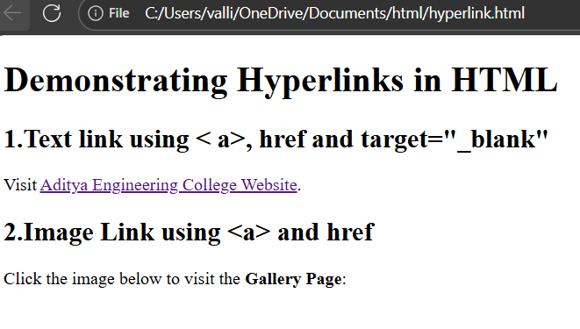

**1.3 profiles**

**AIM** :Create a HTML document that has your image and your friends image with specific height and width. Also when clicked on the images it should navigate to their respective profiles.

**DESCRIPTION:**

This HTML code creates a simple webpage titled "My profile and My friend profile" and demonstrates how to use hyperlinked images to direct users to LinkedIn profiles. The background color of the page is set to lavender using the bgcolor attribute in the <body> tag. At the top, a heading (<h1>) describes the purpose of the page. Two profile images are embedded using the <img> tag, each wrapped inside an <a> anchor tag. These anchor tags are used to create hyperlinks to LinkedIn profiles. The href attribute of the first <a> tag points to the LinkedIn profile of the user

(Sushma Pusala), and the second points to the profile of her friend (Valli Gandam). The target="_blank" attribute ensures that clicking on the images will open the LinkedIn profiles in new browser tabs, preserving the current webpage. Each image is given a specific width and height of 150 pixels for uniformity and includes alt text for accessibility in case the image fails to load.

However, there are a few technical issues in the code. First, the <head> and <body> tags are incorrectly nested; the <body> tag should be inside the <html> and below the

<head>, not inside the <head>. Second, the image source paths

(src="C:\Users\Sushma\OneDrive\Desktop\1.jpg") are local file paths, which will not work on other systems or online browsers, as those files exist only on the creator's local machine. To make the images visible to others, the image files need to be uploaded to a server or hosting platform, and their URLs should be used in the src attribute instead. Despite these issues, the code effectively demonstrates the concept of image-based hyperlinks for profile linking when corrected.

**Program:**

<html>

<head>

<body bgcolor="maroon">

<h1>My Profile and my friends' profiles</h1>

<a href="https://www.linkedin.com/in/tatavarthi-sai-aditya-b121ab34b">

<img src="C:\Users\valli\OneDrive\Desktop\valli pics\eb7c0683-3d8a-439d-b9f2-d8737aaea3d7.jpg" height="250" width="250"></a>

<p>Aditya</p>

<a href="https://www.linkedin.com/in/valli-gandam-20458332b">

<img src="C:\Users\valli\OneDrive\Desktop\valli pics\f19fe139-e57d-49c5-b909-b0fdc60ed240.jpg" height="250" width="250"></a>

<p>pravallika</p>

</body>

</html>

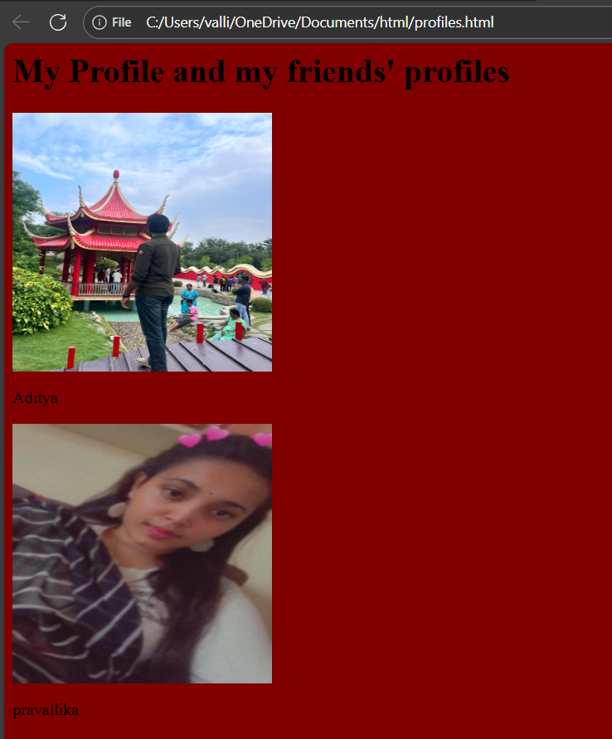

**1.4 Thumbnail image**

**AIM:** Write a HTML program, in such a way that, rather than placing large images on a page, the preferred technique is to use thumbnails by setting the height and width parameters to something like to 100*100 pixels. Each thumbnail image is also a link to a full-sized version of the image. Create an image gallery using this technique **DESCRIPTION:**

This HTML code creates a thumbnail image gallery that displays a set of small images (thumbnails), which can be clicked to open the full-sized versions in new browser tabs. The page uses a <style> block inside the <head> to apply CSS styling. The body has been styled to center-align the content (though test-align is a typo and should be textalign), and the font is intended to be Arial or sans-serif (though there’s a typo frontfamily instead of font-family).

Inside the <body>, a heading (<h1>) titled "My Image Gallery" and a paragraph (<p>) describe the purpose of the gallery. The image gallery itself is created using a <div> with the class gallery, which is styled using Flexbox for responsive layout, spacing (gap: 15px), and wrapping (flex-wrap: wrap). Each image is placed inside an <a> tag with the href pointing to the full-size image. The target="_blank" attribute makes each full image open in a new tab when clicked.

Each <img> tag displays the thumbnail, resized to 150x150 pixels. CSS styles include rounded corners (border-radius: 8px), a border, and a smooth hover effect that slightly enlarges the image and changes the border colour.

**Program:**

<!DOCTYPE html>

<html lang="en">

<head>

<meta charset="UTF-8">

<title>Thumbnail Image Gallery</title>

<style> body{ font-family:Arial,sans-serif; text-align: centre;

}

.gallery{

display: flex; flex wrap: wrap; justify-content:center; gap: 15px; margin-top:20px;

}

.gallery a img{ width: 100px; height: 100px; object-fit: cover; border: 2px solid #ccc; border-radius: 8[x; transition: transform 0.3s;

}

.gallery a img:hover{ transform: scale(1.1); border-color: #666;

}

</style>

</head>

<body bgcolor="beige">

<h1>My Image Gallery</h1>

<p>Click on a thumnail to view the full-sized image</p>

<div class="gallery">

<a href="C:\Users\garag\OneDrive\Desktop\College\me.jpg"target=_blank">

<img src="images/thumb1.jpg" alt="Image-1">

</a>

<a href="C:\Users\garag\OneDrive\Desktop\College\Sushma.jpg"target="_blank">

<img src="images/thumb2.jpg" alt="image-2">

</a>

<a href="C:\Users\garag\OneDrive\Desktop\College\Sruthi.jpg"target="_blank">

<img src="images/thumb3.jpg"alt="image-3">

</a>

<a href="C:\Users\garag\OneDrive\Desktop\College\Pravallika.jpg"target="_blank">

<img src="images/thumb4.jpg"alt="image-4">

</a>

</div>

</body>

</html>

